**Git Push from Eclipse**

# Steps to push project from Eclipse

1. Go to Eclipse 🡪right Click on project to be push into Git .
2. Select Teams🡪Share Project and select

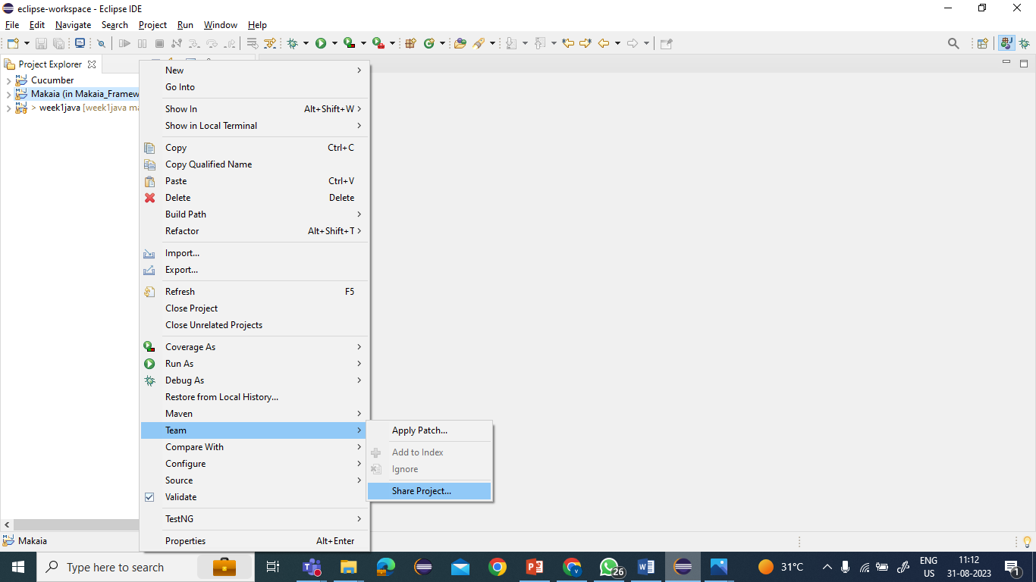

1. A pop window opens to configure Git repository in Local repo

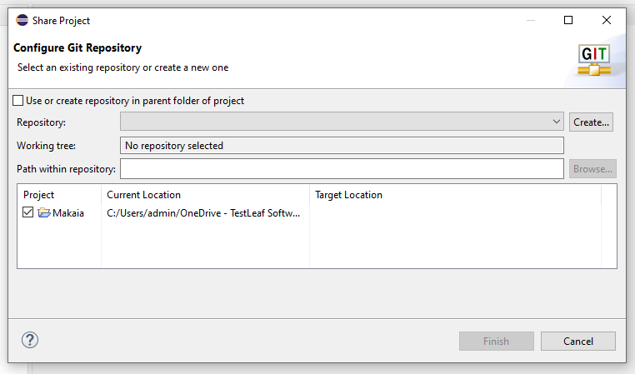

1. Now Click on the check box **Use or create repository in parent folder of Project** and **Select the project**

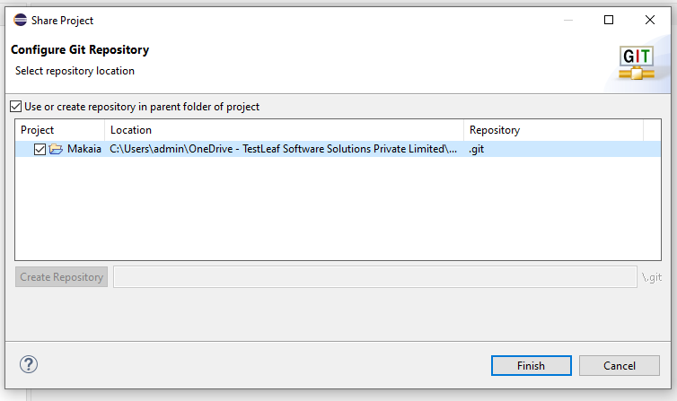

1. Click on **Create repository** and **Finish**



1. Now again do right click on Project 🡪Teams and Click on Commit

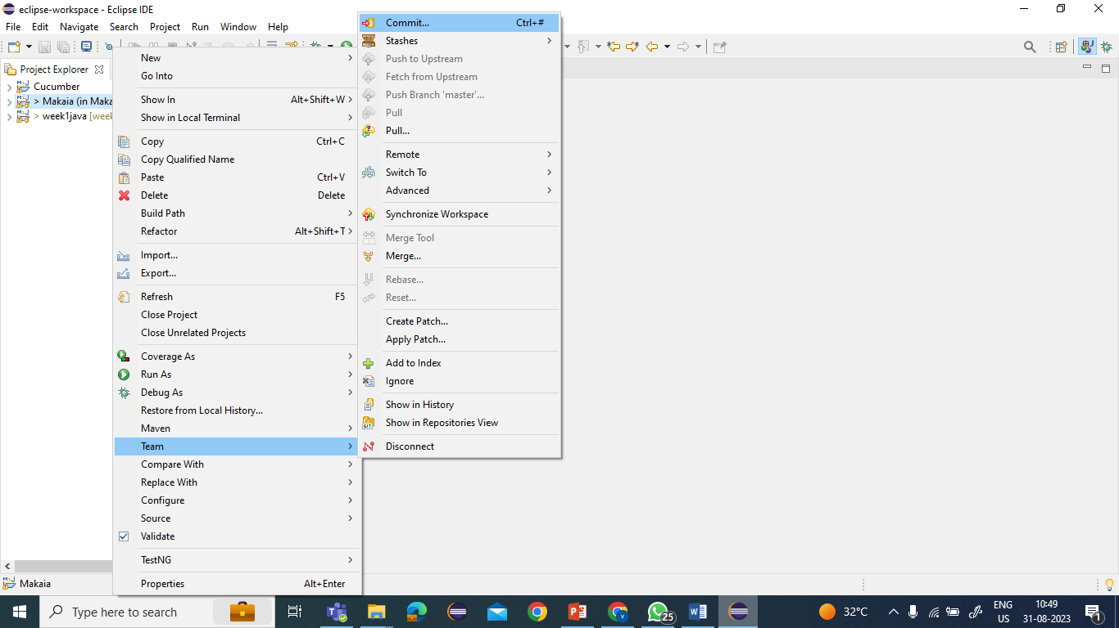

1. Once Clicked , Git staging window will be opened

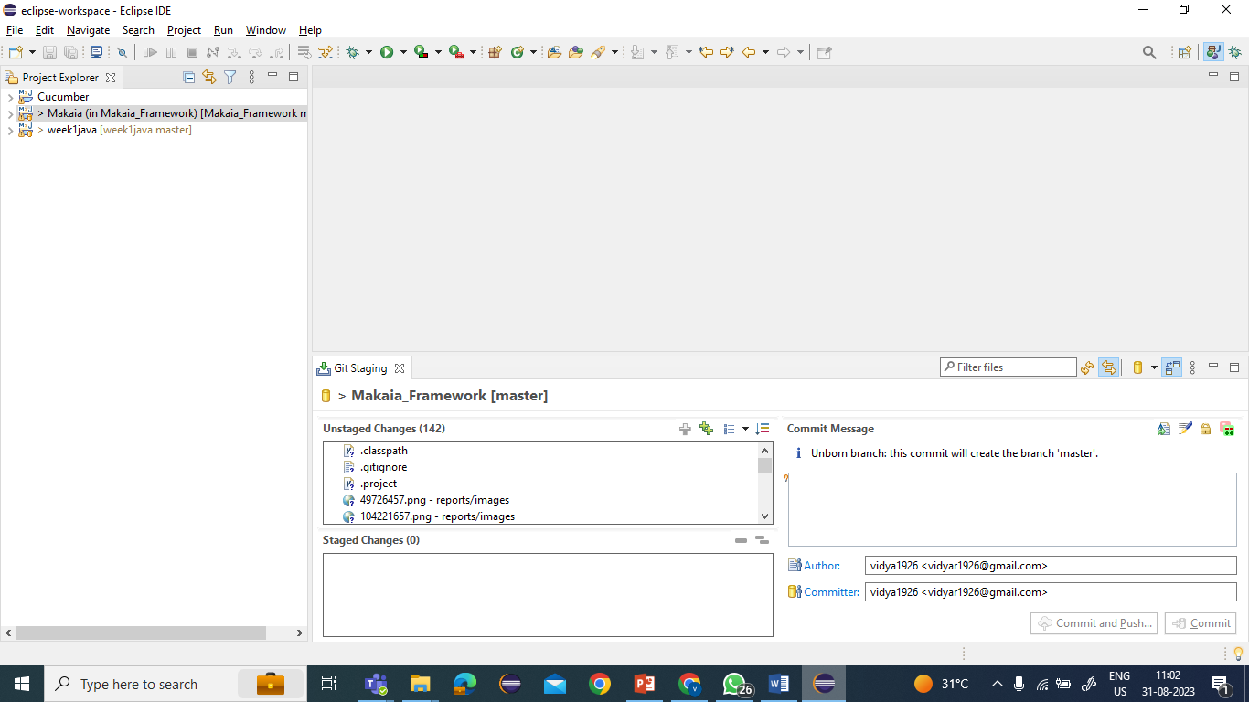

1. Click on the C:\Users\admin\OneDrive - TestLeaf Software Solutions Private Limited\Pictures\Screenshots\Screenshot (307).pngorC:\Users\admin\OneDrive - TestLeaf Software Solutions Private Limited\Pictures\Screenshots\Screenshot (306).png to add the selected files or individually or collectively to staging phase

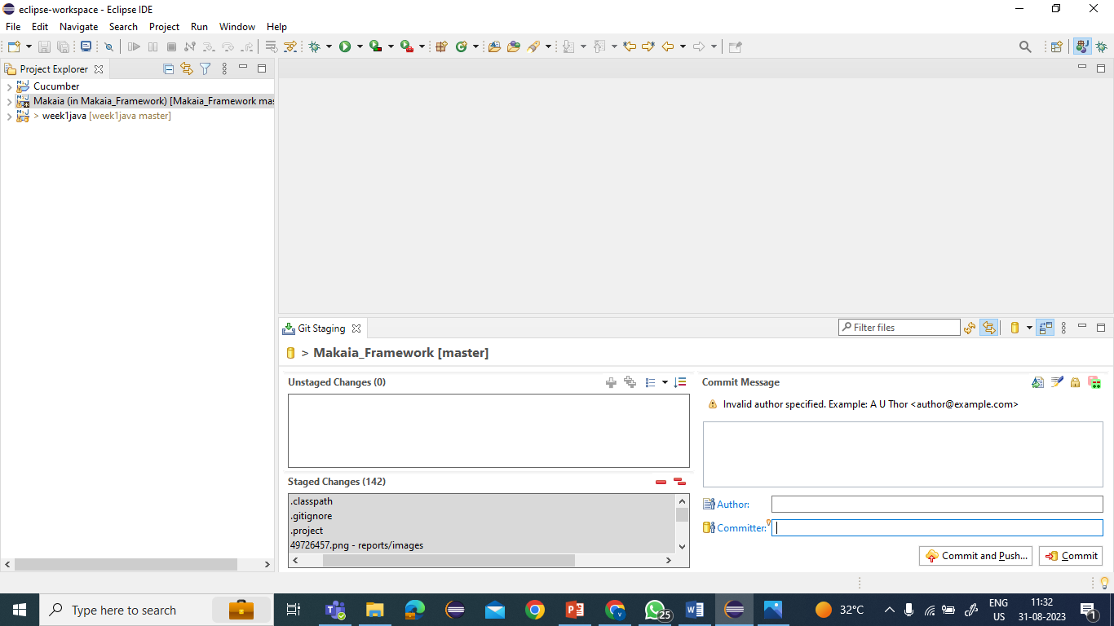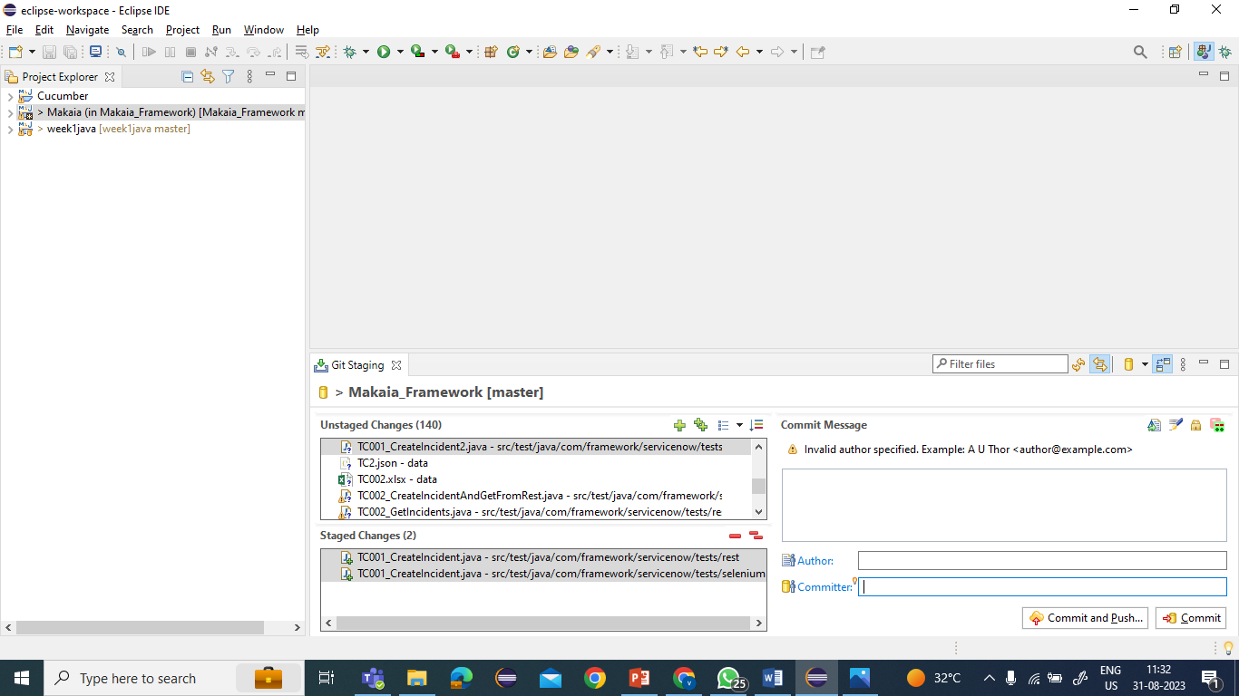

1. Now enter the commit message and add the Git repo username as author and Commiter and click on Commit

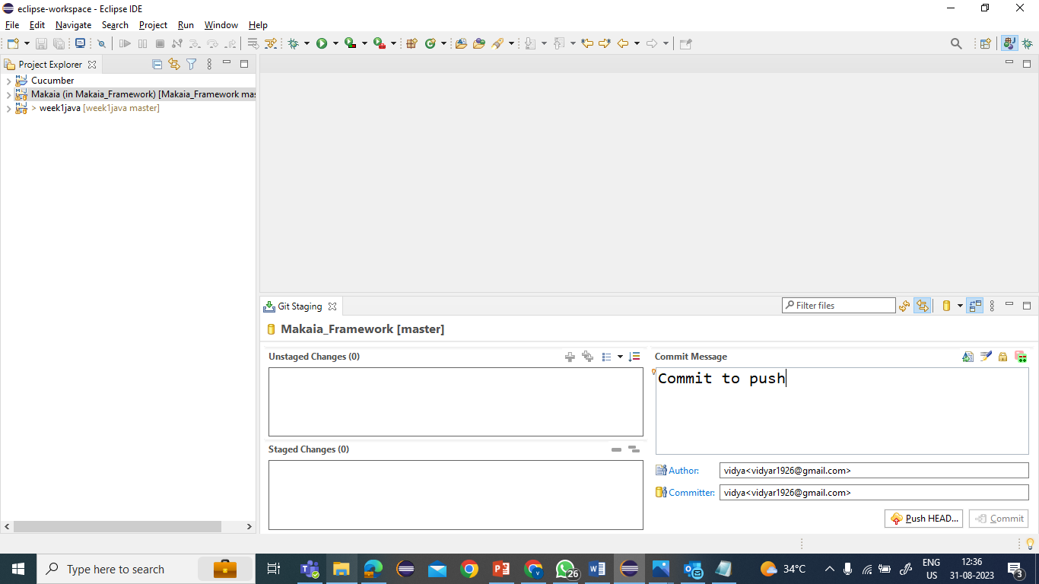

1. Click on Push Head and new window pop will appear  
     
     
   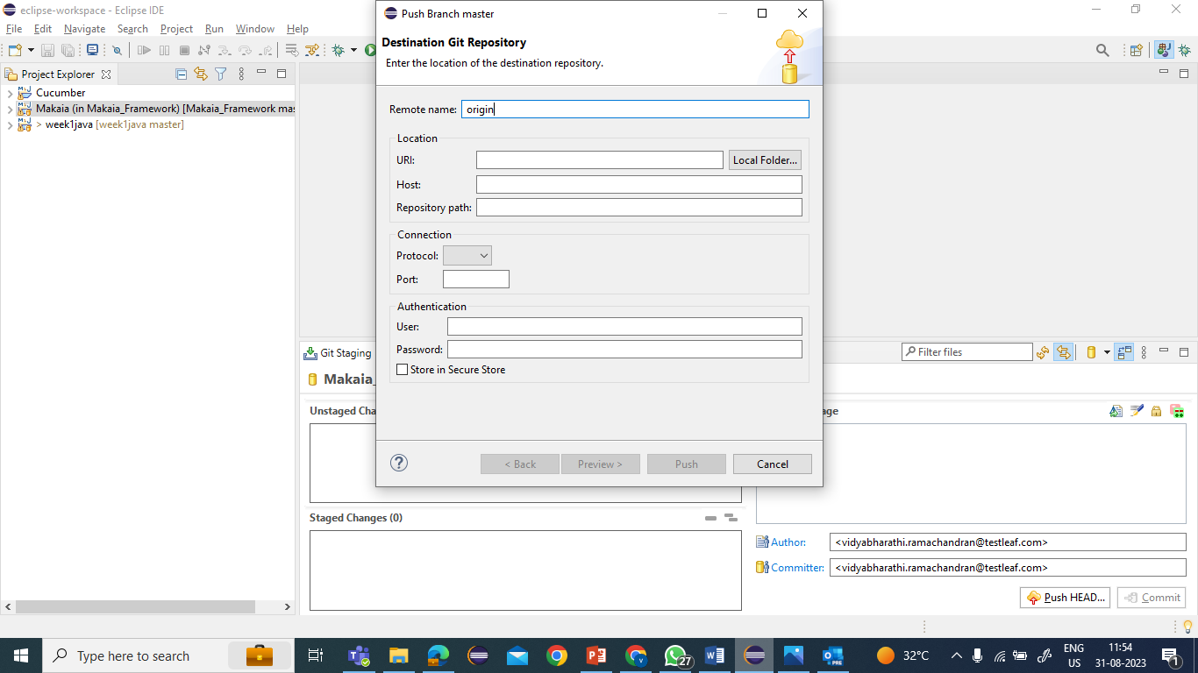
2. Create new repository in Git Repo and add repo URI in Eclipse –Pop up window  
   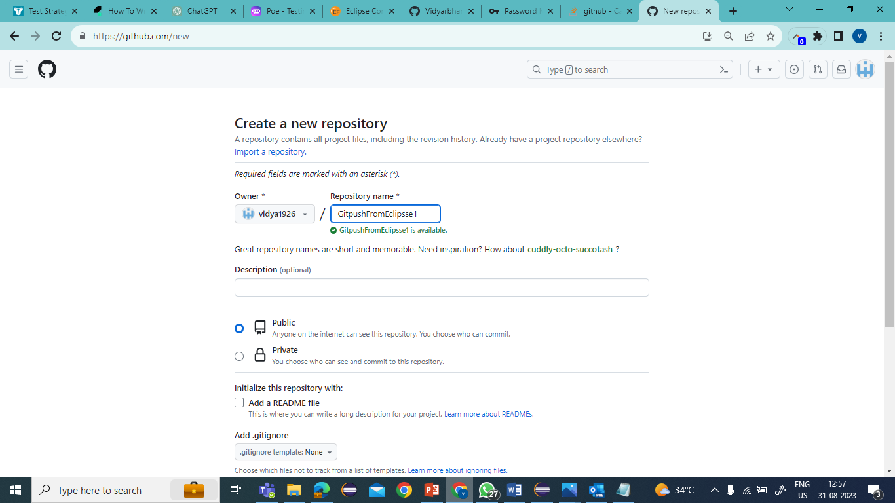  
   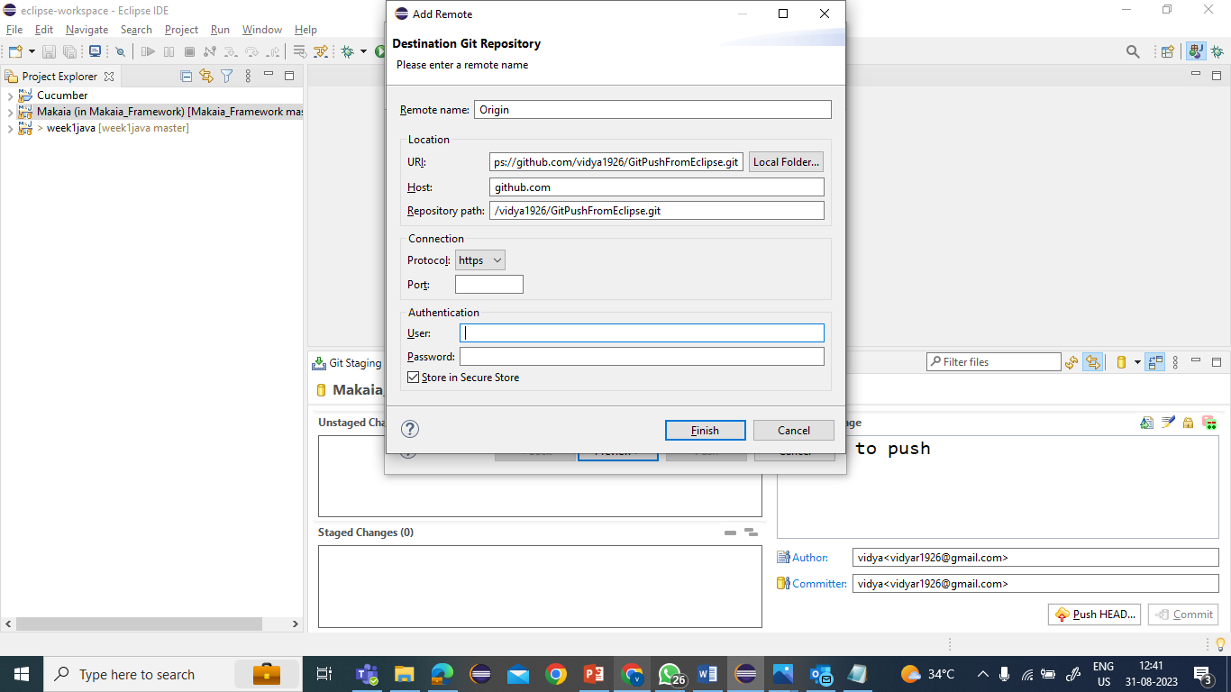
3. Next add the username and password of the git repo under Authentication and click Finish

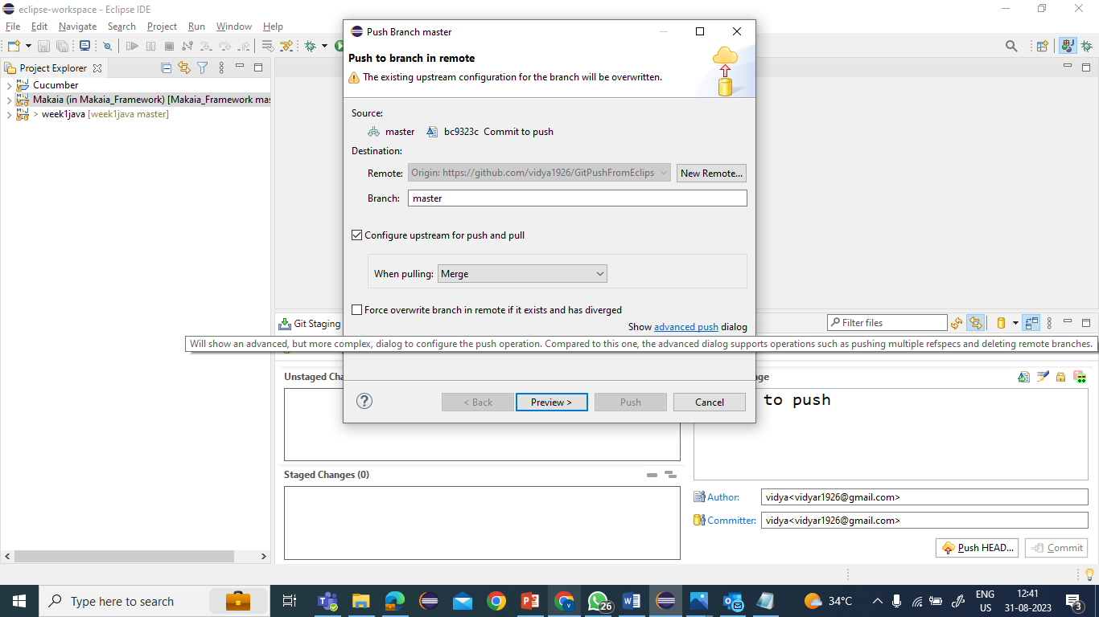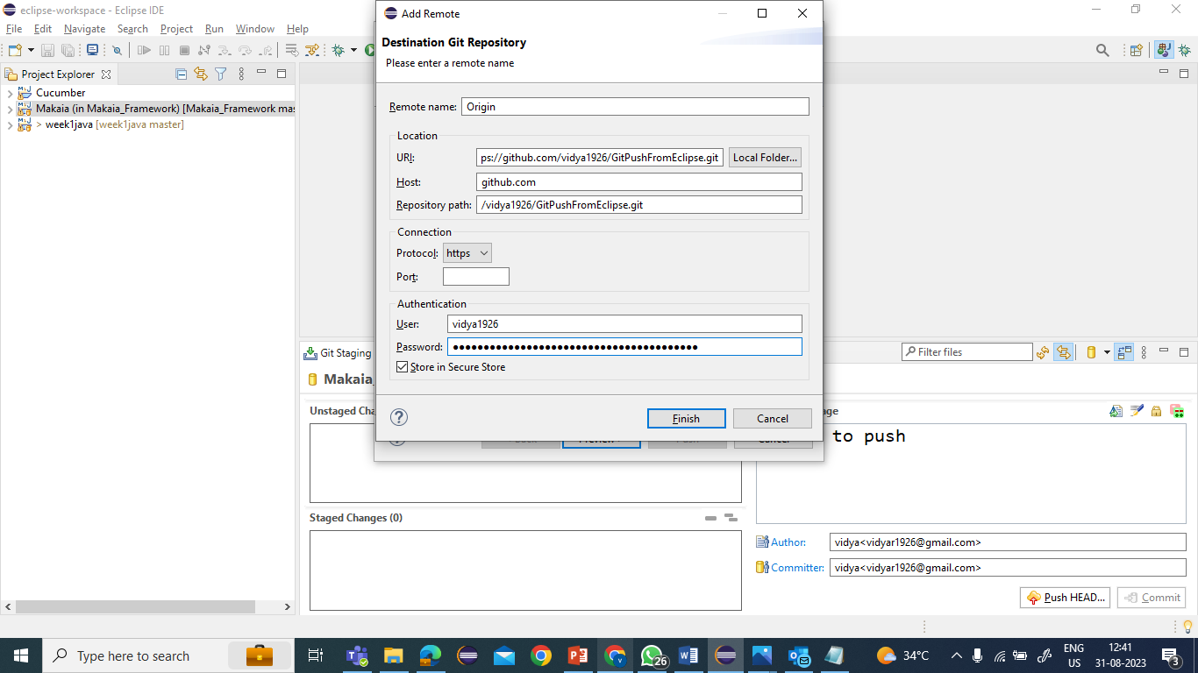

*Note: Use Password as token generated from Git repo   
To Generate token   
 Git Repo🡪 Settings 🡪Developer Settings🡪Personal Access Token 🡪Create token ­and save it for further usage.

1. Click Preview

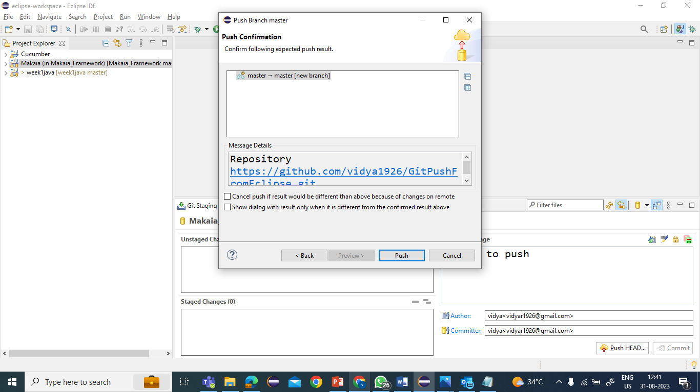

1. Click Push

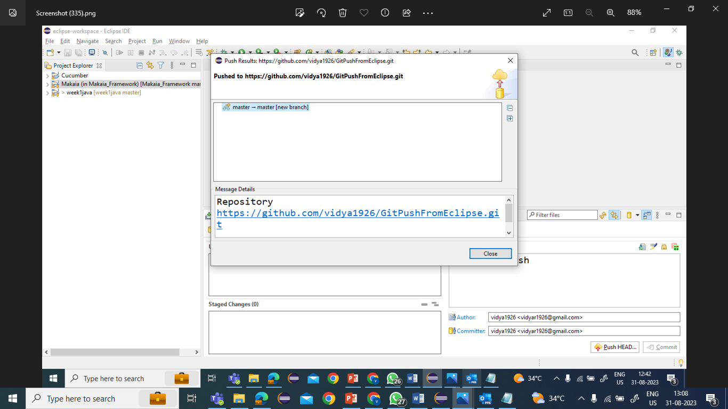

1. Confirm the push is Successful in Git

